|  |  |
| --- | --- |
|  | Virtual Key for Your Repositories [ LockedMe ] |
|  |  |
|  | Sameer Safdar Khan  <https://github.com/SameerKhan0411/Sameer_Khan.git> |

**Project: 1**

**Virtual Key for Your Repositories [ LockedMe ]**

(Writeup)

**Submitted by: Sameer Safdar Khan**

**GitHub repository link:**

<https://github.com/SameerKhan0411/Sameer_Khan.git>

**INDEX**

|  |  |  |
| --- | --- | --- |
| Sr. no. | Content title | Page no. |
|  |  |  |
| 1. | Sprints Planning | 1 |
| 2. | Concepts used in Project. | 2 |
| 3. | Flow Chart/ Flow of the program. | 3 |
| 4. | Development steps of program. | 4 |
| 5. | Unique Selling Points. | 12 |
| 6. | Conclusions. | 13 |

**SPRINTS PLANNING:**

The project is planned to be completed in 2 sprints.

Tasks assumed to be completed in the sprint 1 are:

* Creating the flow of the application.
* Initializing git repository to track changes as development progresses.
* Writing the Java program to fulfil the requirements of the project.

Tasks assumed to be completed in the sprint 2 are:

* Testing the Java program with different kinds of User input.
* Pushing code to GitHub.
* Creating this specification document highlighting application capabilities, appearance, and user interactions.

Page no. 1

**Concepts used in project:**

* ***Collection framework***: The Collection in Java is a framework that provides an architecture to store and manipulate the group of objects. Java Collections can achieve all the operations that you perform on a data such as searching, sorting, insertion, manipulation, and deletion.
* ***File Handling***: File handling in Java is defined as reading and writing data to a file. The particular file class from the package called java.io allows us to handle and work with different formats of files.
* ***Sorting***: Sorting is the process of putting a list or a group of items in a specific order. Some common sorting criteria are: alphabetical or numerical. Sorting can also be done in ascending order (A-Z) or descending order (Z-A). Sorting refers to ordering data in an increasing or decreasing fashion according to some linear relationship among the data items. Sorting can be done on names, numbers and records. That is, sorting greatly improves the efficiency of searching.
* ***Flow Control***: Control flow statements let you control the flow of the execution of the code in your program. In Java programming language, you can control the flow of execution of the code by placing the decision making, branching, looping, and adding conditional blocks.
* ***Recursion***: Recursion in java is a process in which a method calls itself continuously. A method in java that calls itself is called recursive method.
* ***Exception Handling***: The Exception Handling in Java is one of the powerful mechanisms to handle the runtime errors so that the normal flow of the application can be maintained.
* ***Streams API***: The Stream API is used to process collections of objects. A stream is a sequence of objects that supports various methods which can be pipelined to produce the desired result.

**Flow of the program.**

Page no. 2

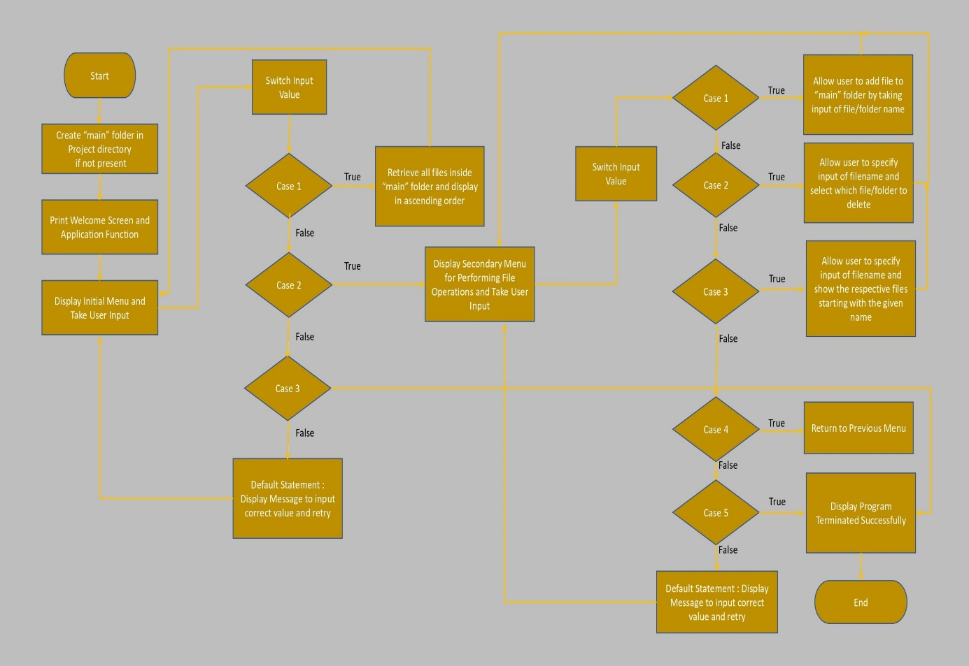

Page no. 3

**Development steps of program.**

The steps involved in the development of program are:

1. Creating project in Eclipse.
2. Java program for entry point of application. [ LockedMeMain.java ]
3. Java program for display of menu options. [ MenuOptions.java ]
4. Java program for menu options handling. [ HandleOptions.java ]
5. Java program for specified file operations. [ FileOperations.java ]

1: Creating a new project in Eclipse

* Open Eclipse
* Go to File -> New -> Project -> Java Project -> Next.
* Type in any project name and click on “Finish.”
* Select your project and go to File -> New -> Class.
* Enter **LockedMeMain** in any class name, check the checkbox “public static void main(String[] args)”, and click on “Finish.”

2: Java program for entry point of application. [ LockedMeMain.java ]

**package** com.lockedme;

**public** **class** LockedMeMain {

**public** **static** **void** main(String[] args) {

FileOperations.*createMainFolderIfNotPresent*("main");

MenuOptions.*printWelcomeScreen*("LockedMe","Sameer Khan");

HandleOptions.*handleWelcomeScreenInput*();

}

}

Page no. 4

3: Java program for display of menu options. [ MenuOptions.java ]

**package** com.lockedme;

**public** **class** MenuOptions {

**public** **static** **void** printWelcomeScreen(String appName, String developerName) {

String companyDetails = String.*format*("*****************************************************\n"

+ "** Welcome to %s.com. \n" + "** This application was developed by %s.\n"

+ "*****************************************************\n", appName, developerName);

String appFunction = "You can use this application to :-\n"

+ "• Retrieve all file names in the \"main\" folder\n"

+ "• Search, add, or delete files in \"main\" folder.\n"

+ "\n**Please be careful to ensure the correct filename is provided for searching or deleting files.**\n";

System.***out***.println(companyDetails);

System.***out***.println(appFunction);

}

**public** **static** **void** displayMenu() {

String menu = "\n\n****** Select any option number from below and press Enter ******\n\n"

+ "1) Retrieve all files inside \"main\" folder\n" + "2) Display menu for File operations\n"

+ "3) Exit program\n";

System.***out***.println(menu);

}

**public** **static** **void** displayFileMenuOptions() {

String fileMenu = "\n\n****** Select any option number from below and press Enter ******\n\n"

+ "1) Add a file to \"main\" folder\n" + "2) Delete a file from \"main\" folder\n"

+ "3) Search for a file from \"main\" folder\n" + "4) Show Previous Menu\n" + "5) Exit program\n";

System.***out***.println(fileMenu);

}

}

Page no. 5

4: Java program for menu options handling. [ HandleOptions.java ]

**package** com.lockedme;

**import** java.util.List;

**import** java.util.Scanner;

**public** **class** HandleOptions {

**public** **static** **void** handleWelcomeScreenInput() {

**boolean** running = **true**;

Scanner sc = **new** Scanner(System.in);

**do** {

**try** {

MenuOptions.displayMenu();

**int** input = sc.nextInt();

**switch** (input) {

**case** 1:

FileOperations.displayAllFiles("main");

**break**;

**case** 2:

HandleOptions.handleFileMenuOptions();

**break**;

**case** 3:

System.out.println("Program exited successfully.");

running = **false**;

sc.close();

System.exit(0);

**break**;

**default**:

System.out.println("Please select a valid option from above.");

}

} **catch** (Exception e) {

System.out.println(e.getClass().getName());

handleWelcomeScreenInput();

}

} **while** (running == **true**);

}

**public** **static** **void** handleFileMenuOptions() {

**boolean** running = **true**;

Scanner sc = **new** Scanner(System.in);

**do** {

**try** {

MenuOptions.displayFileMenuOptions();

FileOperations.createMainFolderIfNotPresent("main");

Page no. 6

**int** input = sc.nextInt();

**switch** (input) {

**case** 1:

System.out.println("Enter the name of the file to be added to the \"main\" folder");

String fileToAdd = sc.next();

FileOperations.createFile(fileToAdd, sc);

**break**;

**case** 2:

System.out.println("Enter the name of the file to be deleted from \"main\" folder");

String fileToDelete = sc.next();

FileOperations.createMainFolderIfNotPresent("main");

List<String> filesToDelete = FileOperations.displayFileLocations(fileToDelete, "main");

String deletionPrompt = "\nSelect index of which file to delete?"

+ "\n(Enter 0 if you want to delete all elements)";

System.out.println(deletionPrompt);

**int** idx = sc.nextInt();

**if** (idx != 0) {

FileOperations.deleteFileRecursively(filesToDelete.get(idx - 1));

} **else** {

**for** (String path : filesToDelete) {

FileOperations.deleteFileRecursively(path);

}

}

**break**;

**case** 3:

System.out.println("Enter the name of the file to be searched from \"main\" folder");

String fileName = sc.next();

FileOperations.createMainFolderIfNotPresent("main");

FileOperations.displayFileLocations(fileName, "main");

**break**;

**case** 4:

**return**;

**case** 5:

Page no. 7

System.out.println("Program exited successfully.");

running = **false**;

sc.close();

System.exit(0);

**default**:

System.out.println("Please select a valid option from above.");

}

} **catch** (Exception e) {

System.out.println(e.getClass().getName());

handleFileMenuOptions();

}

} **while** (running == **true**);

}

}

Page no. 8

5: Java program for specified file operations. [ FileOperations.java ]

**package** com.lockedme;

**import** java.io.File;

**import** java.io.IOException;

**import** java.nio.file.Files;

**import** java.nio.file.Path;

**import** java.nio.file.Paths;

**import** java.util.ArrayList;

**import** java.util.Arrays;

**import** java.util.Collections;

**import** java.util.List;

**import** java.util.Scanner;

**import** java.util.stream.Collectors;

**import** java.util.stream.IntStream;

**public** **class** FileOperations {

**public** **static** **void** createMainFolderIfNotPresent(String folderName) {

File file = **new** File(folderName);

**if** (!file.exists()) {

file.mkdirs();

}

}

**public** **static** **void** displayAllFiles(String path) {

FileOperations.createMainFolderIfNotPresent("main");

System.out.println("Displaying all files with directory structure in ascending order\n");

List<String> filesListNames = FileOperations.listFilesInDirectory(path, 0, **new** ArrayList<String>());

System.out.println("Displaying all files in ascending order\n");

Collections.sort(filesListNames);

filesListNames.stream().forEach(System.out::println);

}

**public** **static** List<String> listFilesInDirectory(String path, **int** indentationCount, List<String> fileListNames) {

File dir = **new** File(path);

File[] files = dir.listFiles();

List<File> filesList = Arrays.asList(files);

Collections.sort(filesList);

**if** (files != **null** && files.length > 0) {

**for** (File file : filesList) {

System.out.print(" ".repeat(indentationCount * 2));

**if** (file.isDirectory()) {

System.out.println("`-- " + file.getName());

Page no. 9 9999919

fileListNames.add(file.getName());

listFilesInDirectory(file.getAbsolutePath(), indentationCount + 1, fileListNames);

} **else** {

System.out.println("|-- " + file.getName());

fileListNames.add(file.getName());

}

}

} **else** {

System.out.print(" ".repeat(indentationCount * 2));

System.out.println("|-- Empty Directory");

}

System.out.println();

**return** fileListNames;

}

**public** **static** **void** createFile(String fileToAdd, Scanner sc) {

FileOperations.createMainFolderIfNotPresent("main");

Path pathToFile = Paths.get("./main/" + fileToAdd);

**try** {

Files.createDirectories(pathToFile.getParent());

Files.createFile(pathToFile);

System.out.println(fileToAdd + " created successfully");

System.out.println("Would you like to add some content to the file? (Y/N)");

String choice = sc.next().toLowerCase();

sc.nextLine();

**if** (choice.equals("y")) {

System.out.println("\n\nInput content and press enter\n");

String content = sc.nextLine();

Files.write(pathToFile, content.getBytes());

System.out.println("\nContent written to file " + fileToAdd);

System.out.println("Content can be read using Notepad or Notepad++");

}

} **catch** (IOException e) {

System.out.println("Failed to create file " + fileToAdd);

System.out.println(e.getClass().getName());

}

}

**public** **static** List<String> displayFileLocations(String fileName, String path) {

List<String> fileListNames = **new** ArrayList<>();

FileOperations.searchFileRecursively(path, fileName, fileListNames);

**if** (fileListNames.isEmpty()) {

System.out.println("\n\n***** Couldn't find any file with given file name \"" + fileName + "\" *****\n\n");

} **else** {

System.out.println("\n\nFound file at below location(s):");

List<String> files = IntStream.range(0, fileListNames.size())

.mapToObj(index -> (index + 1) + ": " + fileListNames.get(index)).collect(Collectors.toList());

Page no. 10

files.forEach(System.out::println);

}

**return** fileListNames;

}

**public** **static** **void** searchFileRecursively(String path, String fileName, List<String> fileListNames) {

File dir = **new** File(path);

File[] files = dir.listFiles();

List<File> filesList = Arrays.asList(files);

**if** (files != **null** && files.length > 0) {

**for** (File file : filesList) {

**if** (file.getName().startsWith(fileName)) {

fileListNames.add(file.getAbsolutePath());

}

**if** (file.isDirectory()) {

searchFileRecursively(file.getAbsolutePath(), fileName, fileListNames);

}

}

}

}

**public** **static** **void** deleteFileRecursively(String path) {

File currFile = **new** File(path);

File[] files = currFile.listFiles();

**if** (files != **null** && files.length > 0) {

**for** (File file : files) {

String fileName = file.getName() + " at " + file.getParent();

**if** (file.isDirectory()) {

deleteFileRecursively(file.getAbsolutePath());

}

**if** (file.delete()) {

System.out.println(fileName + " deleted successfully");

} **else** {

System.out.println("Failed to delete " + fileName);

}

}

}

String currFileName = currFile.getName() + " at " + currFile.getParent();

**if** (currFile.delete()) {

System.out.println(currFileName + " deleted successfully");

} **else** {

System.out.println("Failed to delete " + currFileName);

}

}

}

Page no. 11

**Unique Selling Points of the Application.**

1. The application is designed to keep on running and taking user inputs even after exceptions occur.
2. To terminate the application, appropriate option needs to be selected.
3. The application can take any file/folder name as input.
4. User is also provided the option to write content if they want into the newly created file.
5. The application also allows user to delete files.
6. The user is able to seamlessly switch between options or return to previous menu.

Page no. 12

**Conclusion**

Further enhancements to the application can be made which may include:

* Conditions to check if user is allowed to delete the file or add the file at the specific locations.
* Retrieving files/folders by different criteria like Last Modified, Type, etc.
* Allowing user to append data to the file.

Page no. 13